Lab Sheet: 1
Objective:
- To design ER diagrams and convert entities and relationships into relational tables using proper schema notation.
Instructions:
- Open your preferred Database Management System (DBMS) tool.
- Create a new database named DBMS_YourName.
- Draw ER diagrams for the given scenarios.
- Convert entities and relationships into relational schemas.
- Create tables using the derived schemas.

PART A – COLLEGE DATABASE
STUDENT ( USN, SName, Address, Phone, Gender )
SEMSEC ( SSID, Sem, Sec )
CLASS ( USN, SSID )
SUBJECT ( Subcode, Title, Sem, Credits )
IAMARKS ( USN, Subcode, SSID, Test1, Test2, Test3, FinalIA ) 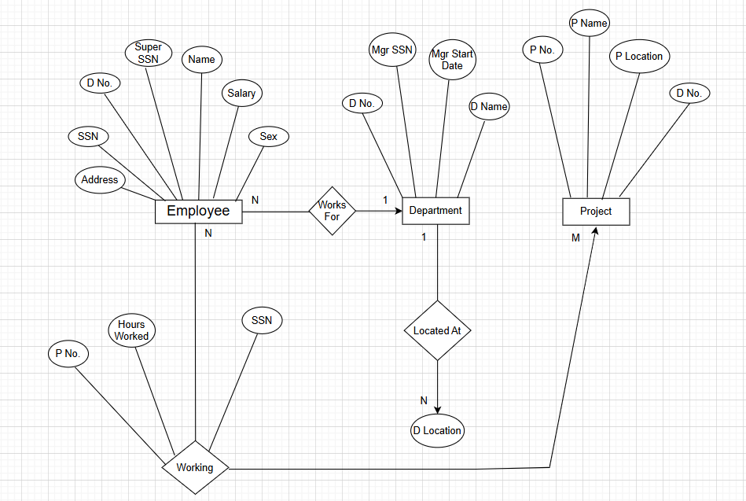

PART B – COMPANY DATABASE
EMPLOYEE ( SSN, Name, Address, Sex, Salary, Superssn, Dno )
DEPARTMENT ( Dno, Dname, Mgrssn, Mgrstartdate )
DLOCATION ( Dno, Dloc )
PROJECT ( PNo, PName, PLocation, DNo )
WORKS_ON ( SSN, PNo, Hours )
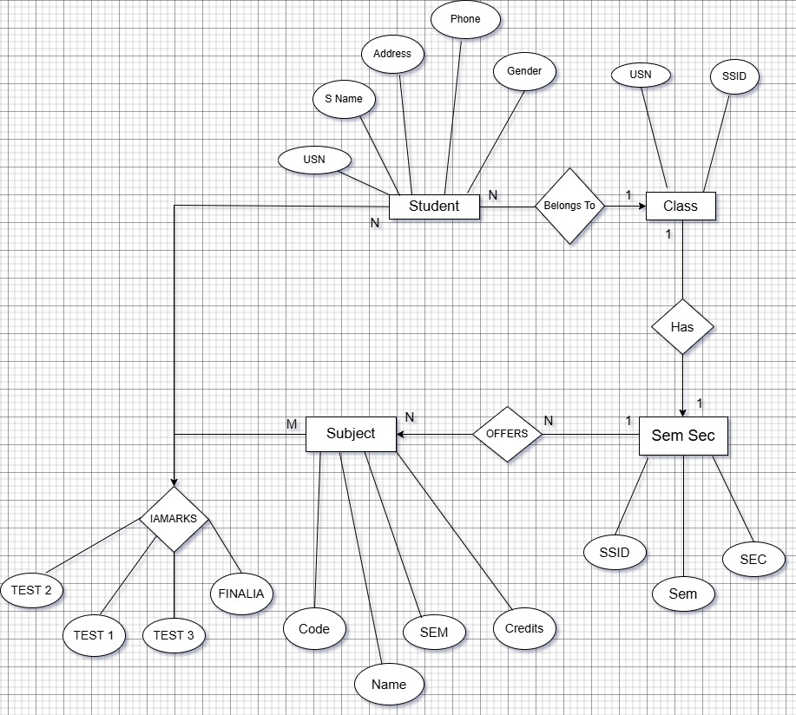
PART C – CUSTOMER SALE SCHEMA
Database Schema for a customer-sale scenario
Customer(Cust id : integer, cust_name: string)
Item(item_id: integer, item_name:string, price: integer)
Sale(bill_no:integer,bill_data:date,cust_id: integer, item_id: integer, qty_sold: integer)

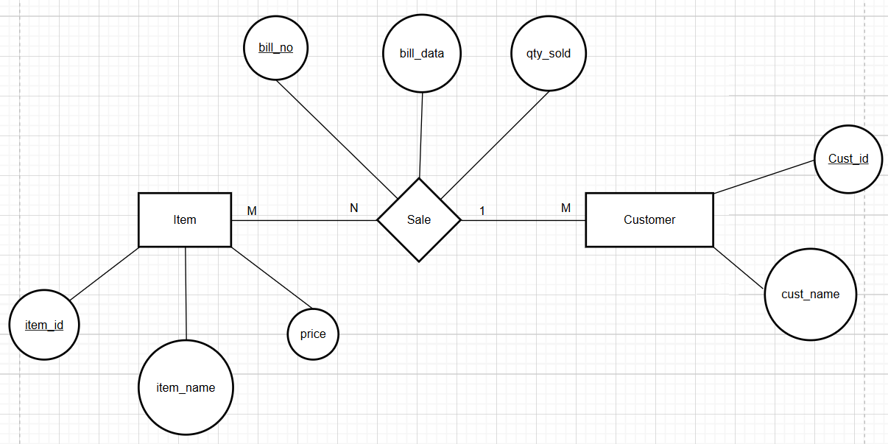

DDL Questions (Data Definition Language):
1. Write SQL statements to create all the above relations with appropriate PRIMARY KEY and FOREIGN KEY constraints.
CREATE database DBMS_Ishaan;
CREATE TABLE STUDENT (
USN VARCHAR(10) PRIMARY KEY,
SName VARCHAR(50) NOT NULL,
Address VARCHAR(100),
Phone VARCHAR(15),
Gender CHAR(1) CHECK (Gender IN ('M', 'F', 'O'))
);
CREATE TABLE SEMSEC (
SSID VARCHAR(10) PRIMARY KEY,
Sem INT CHECK (Sem BETWEEN 1 AND 8),
Sec CHAR(1)
);
CREATE TABLE CLASS (
USN VARCHAR(10),
SSID VARCHAR(10),
PRIMARY KEY (USN, SSID),
FOREIGN KEY (USN) REFERENCES STUDENT(USN),
FOREIGN KEY (SSID) REFERENCES SEMSEC(SSID)
);
CREATE TABLE SUBJECT (
Subcode VARCHAR(10) PRIMARY KEY,
Title VARCHAR(100) NOT NULL,
Sem INT,
Credits INT
);
CREATE TABLE IAMARKS (
USN VARCHAR(10),
Subcode VARCHAR(10),
SSID VARCHAR(10),
Test1 INT DEFAULT 0,
Test2 INT DEFAULT 0,
Test3 INT DEFAULT 0,
FinalIA INT,
PRIMARY KEY (USN, Subcode, SSID),
FOREIGN KEY (USN) REFERENCES STUDENT(USN) ,
FOREIGN KEY (Subcode) REFERENCES SUBJECT(Subcode) ,
FOREIGN KEY (SSID) REFERENCES SEMSEC(SSID)
);
CREATE TABLE DEPARTMENT (
Dno INT PRIMARY KEY,
Dname VARCHAR(50) NOT NULL,
Mgrssn CHAR(9),
Mgrstartdate DATE
);
CREATE TABLE EMPLOYEE (
SSN CHAR(9) PRIMARY KEY,
Name VARCHAR(50) NOT NULL,
Address VARCHAR(100),
Sex CHAR(1) CHECK (Sex IN ('M', 'F')),
Salary DECIMAL(10, 2),
Superssn CHAR(9),
Dno INT,
FOREIGN KEY (Superssn) REFERENCES EMPLOYEE(SSN),
FOREIGN KEY (Dno) REFERENCES DEPARTMENT(Dno)
);
ALTER TABLE DEPARTMENT
ADD CONSTRAINT FK_Mgr
FOREIGN KEY (Mgrssn) REFERENCES EMPLOYEE(SSN);
CREATE TABLE DLOCATION (
Dno INT,
Dloc VARCHAR(50),
PRIMARY KEY (Dno, Dloc),
FOREIGN KEY (Dno) REFERENCES DEPARTMENT(Dno)
);
CREATE TABLE PROJECT (
PNo INT PRIMARY KEY,
PName VARCHAR(50) NOT NULL,
PLocation VARCHAR(50),
DNo INT,
FOREIGN KEY (DNo) REFERENCES DEPARTMENT(Dno)
);
CREATE TABLE WORKS_ON (
SSN CHAR(9),
PNo INT,
Hours DECIMAL(4, 1),
PRIMARY KEY (SSN, PNo),
FOREIGN KEY (SSN) REFERENCES EMPLOYEE(SSN) ,
FOREIGN KEY (PNo) REFERENCES PROJECT(PNo)
);
CREATE TABLE Customer (
Cust_id INT PRIMARY KEY,
cust_name VARCHAR(100) NOT NULL
);

CREATE TABLE Item (
item_id INT PRIMARY KEY,
item_name VARCHAR(100) NOT NULL,
price INT
);

CREATE TABLE Sale (
bill_no INT,
bill_data DATE,
cust_id INT,
item_id INT,
qty_sold INT,
-- Composite Primary Key: Allows multiple items per bill
PRIMARY KEY (bill_no, item_id),
FOREIGN KEY (cust_id) REFERENCES Customer(Cust_id),
FOREIGN KEY (item_id) REFERENCES Item(item_id)
);

2. Add a new column Email to the STUDENT relation.
ALTER TABLE STUDENT
ADD Email VARCHAR(100);
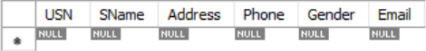

3. Apply NOT NULL constraints to Salary and Price attributes
ALTER TABLE EMPLOYEE
MODIFY Salary DECIMAL(10, 2) NOT NULL;
4. Rename attribute SName to StudentName in STUDENT relation
ALTER TABLE STUDENT
RENAME COLUMN SName TO StudentName;
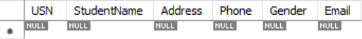
5. Drop the DLOCATION relation.
DROP TABLE DLOCATION;
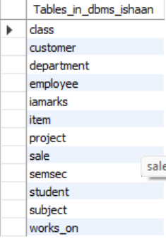
DML Questions (Data Manipulation Language):
1. Insert at least 10 tuples into CUSTOMER, ITEM, and SALE relations.
INSERT INTO Customer (Cust_id, cust_name) VALUES
(1, 'Amit Sharma'),
(2, 'Priya Singh'),
(3, 'John Doe'),
(4, 'Sita Verma'),
(5, 'Rajesh Kumar'),
(6, 'Ananya Iyer'),
(7, 'Vikram Rathore'),
(8, 'Megha Gupta'),
(9, 'Suresh Raina'),
(10, 'Kavita Reddy');

INSERT INTO Item (item_id, item_name, price) VALUES
(101, 'Laptop', 55000),
(102, 'Smartphone', 25000),
(103, 'Headphones', 2500),
(104, 'Smartwatch', 5000),
(105, 'Keyboard', 1200),
(106, 'Gaming Mouse', 1800),
(107, 'Monitor', 12000),
(108, 'USB Drive 64GB', 800),
(109, 'External Hard Drive', 4500),
(110, 'Webcam', 3000);

INSERT INTO Sale (bill_no, bill_data, cust_id, item_id, qty_sold) VALUES
(5001, '2026-01-10', 1, 101, 1),
(5001, '2026-01-10', 1, 105, 1),
(5002, '2026-01-12', 2, 102, 1),
(5003, '2026-01-15', 3, 103, 2),
(5004, '2026-01-18', 4, 108, 5),
(5005, '2026-01-20', 5, 104, 1),
(5006, '2026-01-22', 6, 110, 1),
(5007, '2026-01-25', 7, 107, 2),
(5008, '2026-02-01', 8, 109, 1),
(5009, '2026-02-05', 9, 106, 3),
(5010, '2026-02-10', 10, 102, 1);
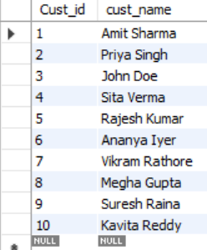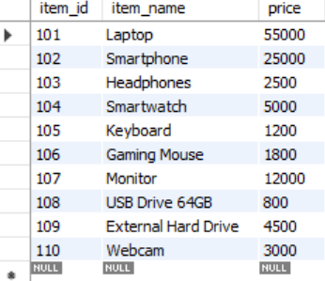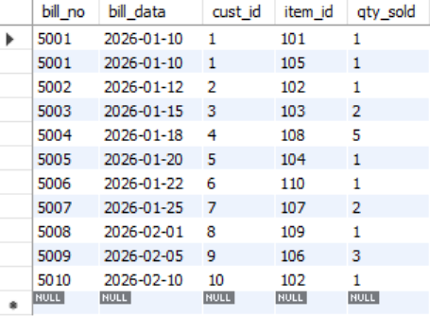

2. List all bills of the current date with customer names and item names.
SELECT
S.bill_no,
S.bill_data,
C.cust_name,
I.item_name,
S.qty_sold
FROM
Sale S
JOIN
Customer C ON S.cust_id = C.Cust_id
JOIN
Item I ON S.item_id = I.item_id
WHERE
S.bill_data = CURDATE();
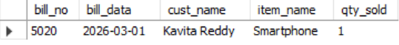
3. Display total bill amount using quantity and price.
SELECT
S.bill_no,
C.cust_name,
I.item_name,
S.qty_sold,
I.price,
(S.qty_sold * I.price) AS Total_Bill_Amount
FROM
Sale S
JOIN
Customer C ON S.cust_id = C.Cust_id
JOIN
Item I ON S.item_id = I.item_id
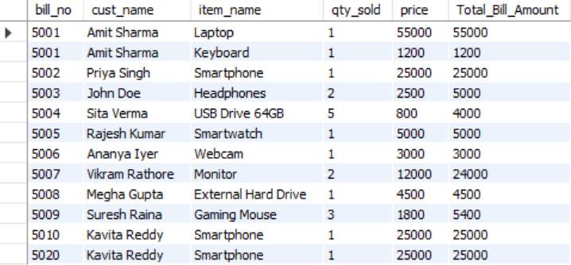
4. List customers who purchased products priced above 200.
SELECT DISTINCT
C.cust_name
FROM
Customer C
JOIN
Sale S ON C.Cust_id = S.cust_id
JOIN
Item I ON S.item_id = I.item_id
WHERE
I.price > 200;
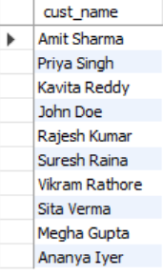
5. Count the number of products purchased by each customer.
SELECT
C.cust_name,
COUNT(S.item_id) AS Number_of_Products
FROM
Customer C
LEFT JOIN
Sale S ON C.Cust_id = S.cust_id
GROUP BY
C.Cust_id, C.cust_name;
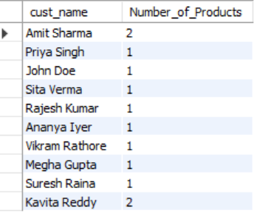
6. List products purchased by customer having Cust_id = 5.
SELECT
I.item_name
FROM
Item I
JOIN
Sale S ON I.item_id = S.item_id
WHERE
S.cust_id = 5;
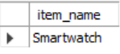
7. Create a VIEW showing bill_no, bill_date, cust_id, item_id, price, qty,sold, amount.
CREATE VIEW Sale_Detailed_View AS
SELECT
S.bill_no,
S.bill_data,
S.cust_id,
S.item_id,
I.price,
S.qty_sold,
(S.qty_sold * I.price) AS amount
FROM
Sale S
JOIN
Item I ON S.item_id = I.item_id;
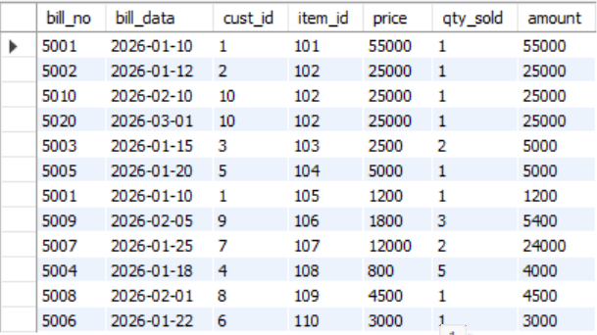
8. Create a VIEW showing daily sales date-wise for the last one week.
CREATE VIEW Last_Week_Sales_View AS
SELECT
bill_data,
SUM(qty_sold * price) AS total_daily_sales
FROM
Sale S
JOIN
Item I ON S.item_id = I.item_id
WHERE
bill_data >= DATE_SUB(CURDATE(), INTERVAL 7 DAY)
GROUP BY
bill_data;
